Please take care of this laptop
Keep liquids and food away from your laptop!! | Use a microfiber cloth to clean your screen when needed.  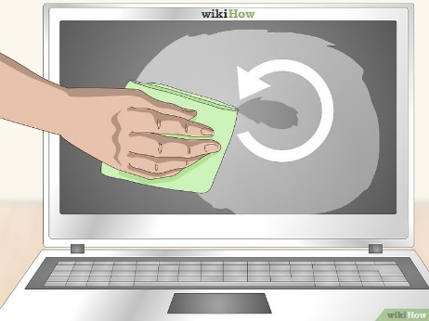
Keep laptop in an area that is clean and free of dust, always place on a flat surface. | Clear items from your laptop “before” you close the lid (pencils, flash drives or other hard objects can damage the screen when you close the lid)  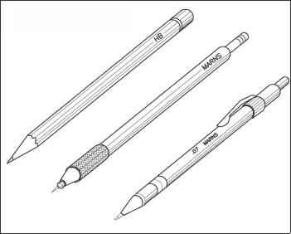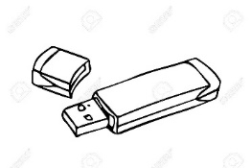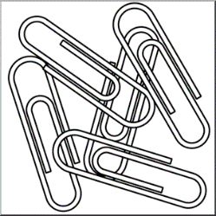
Keep laptop vents clear of dust and hair  Use a microfiber cloth or a cotton ball that is lightly dipped in isopropyl alcohol to clean the keys on the keyboard. Please do so on a regular basis at least  once a week.  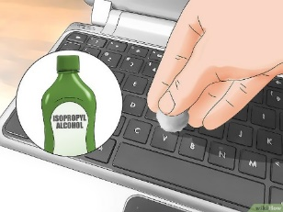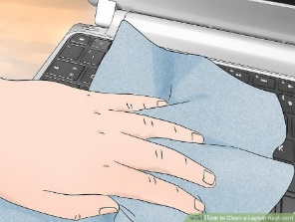 | Safeguard the laptop from extreme temperature changes. Warmer months are coming and leaving the laptop in a hot car will damage it. It will also expose it to thieves.  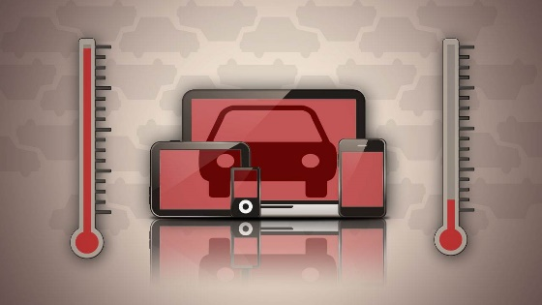
Be careful with placing any heavy items on the laptop. Pressure can crack the casing and severely damage the screen.  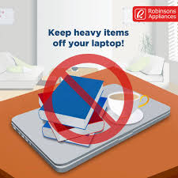 | Please use a bag to carry your laptop, the style is unimportant, it only needs to be large enough and sturdy enough to carry your laptop and its accessories.  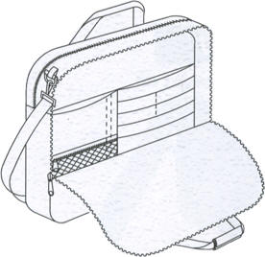
Roll up your power cords, they can be trip hazards!! Be careful where you place them.  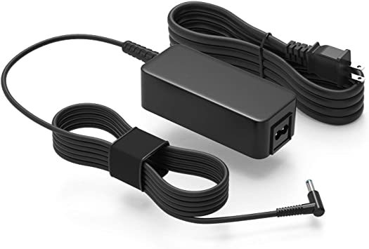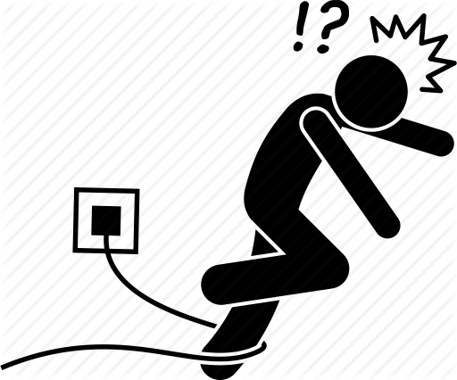 | Never yank a power cord from a laptop or a wall, it can cause serious damage!!  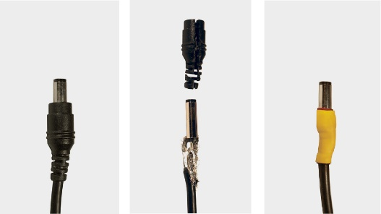
Please be aware that this laptop will be essential in helping you complete your coursework during these challenging times. It is extremely important that you take the appropriate steps to safeguard it!

Happy Computing!!

