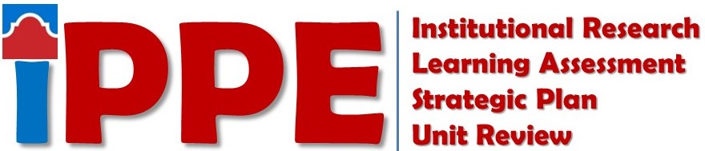
Fall 2020
SAC SCORES Submission Checklist
Items listed below must be submitted to the SAC SCORES file site by 9/25/2020

STUDENT SUCCESS
Staff
☐ Institutional Research: Use of Data Form - Non Academic
Directors and Department Leads
☐ Institutional Research: Use of Data Form - Non Academic
☐ Learning Assessment: Learning Assessment Reflection – Student Success Form
☐ Learning Assessment: Learning Assessment Reflection – Org Chart AY 20-21
☐ Strategic Planning: Strategic Plan
☐ Strategic Planning: Analysis Questions

ACADEMIC SUCCESS
Faculty
☐ Institutional Research: Use of Data Form – Academic
Staff
☐ Institutional Research: Use of Data Form – Academic
Program Coordinators/Discipline Assessment Representatives
☐ Institutional Research: Use of Data Form – Rubric Discipline
☐ Learning Assessment: Learning Assessment Reflection – Academic Success Form
☐ Learning Assessment: eLumen Action Plan(s) image (if applicable)
☐ Learning Assessment: Discipline Assessment Validation Form
☐ Strategic Planning: Strategic Plan
☐ Strategic Planning: Analysis Questions
Chairs
☐ Strategic Planning: Strategic Plan
☐ Strategic Planning: Analysis Questions

COLLEGE SERVICES
Staff
☐ Institutional Research: Use of Data Form - Non Academic
Directors and Department Leads
☐ Institutional Research: Use of Data Form - Non Academic
☐ Strategic Planning: Strategic Plan
☐ Strategic Planning: Analysis Questions

For SAC SCORES Assistance Contact
Strategic Planning Forms  Ester Coronado  Sac-strategicpl@alamo.edu | Institutional Research Forms  Savithra Eratne  Seratne@alamo.edu | Learning Assessment Forms  Rosalind Ong  Sac-slos@alamo.edu

