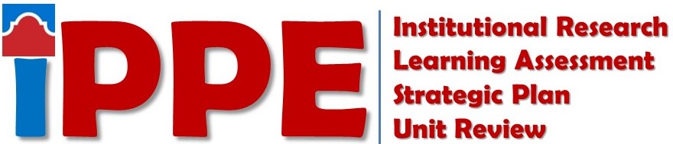
Spring 2022
SAC SCORES Submission Checklist
Items listed below must be submitted to the SAC SCORES file site by 5 p.m. 3/11/2022

STUDENT SUCCESS
Staff
☐ Optional: IR 741 (Use of Data Form - Non-Academic)
Directors and Department Leads
☐ REQUIRED: SP 1 (Strategic Plan)
☐ REQUIRED: SP 2 (Strategic Planning Outcomes Analysis)
☐ Optional: IR 741 (Use of Data Form - Non-Academic)
☐ Optional: LA 1 (Learning Assessment Reflection – Student Success Form)

ACADEMIC SUCCESS
Faculty
☐ Optional: IR 711 (Use of Data Form - FACULTY)
☐ Optional: Upload not Required - SLO by Term Report (Learning Assessment -For discipline meeting)
Staff
☐ Optional: IR 741 (Use of Data Form - Non-Academic)
Program Coordinators/Discipline Assessment Representatives
☐ REQUIRED: SP 1 (Strategic Plan)
☐ REQUIRED: SP 2 (Strategic Planning Outcomes Analysis)
☐ Optional: IR 712 (Use of Data Form - RUBRIC)
☐ Optional: IR 713 (Use of Data Form - PROGRAM)
☐ Optional: LA 2 (Learning Assessment Reflection– ACADEMIC Success Form for AA, AS, AAT, & CORE)
- (AA, AS, AAT, AAT, CORE – Primarily Arts & Science disciplines)
☐ Optional: LA 3 (Learning Assessment Reflection – ACADEMIC Success Form for AAS)
- (AAS/Primarily CTE disciplines) ONE FOR EACH DEGREE

Chairs/Directors/Coordinators
☐ REQUIRED: SP 1 (Strategic Plan)
☐ REQUIRED: SP 2 (Strategic Planning Outcomes Analysis)

COLLEGE SERVICES
Staff
☐ Optional: IR 741 (Use of Data Form - Non-Academic)
Directors and Department Leads
☐ REQUIRED: SP 1 (Strategic Plan)
☐ REQUIRED: SP 2 (Strategic Planning Outcomes Analysis)
☐ Optional: IR 741 (Use of Data Form - Non-Academic)

For SAC SCORES Assistance Contact
Strategic Planning Forms  Ester Coronado  SAC-STRATEGICPL@ALAMO.EDU | Institutional Research Forms  Savithra Eratne  SERATNE@ALAMO.EDU | Learning Assessment Forms  Rosalind Ong  SAC-SLOS@ALAMO.EDU

